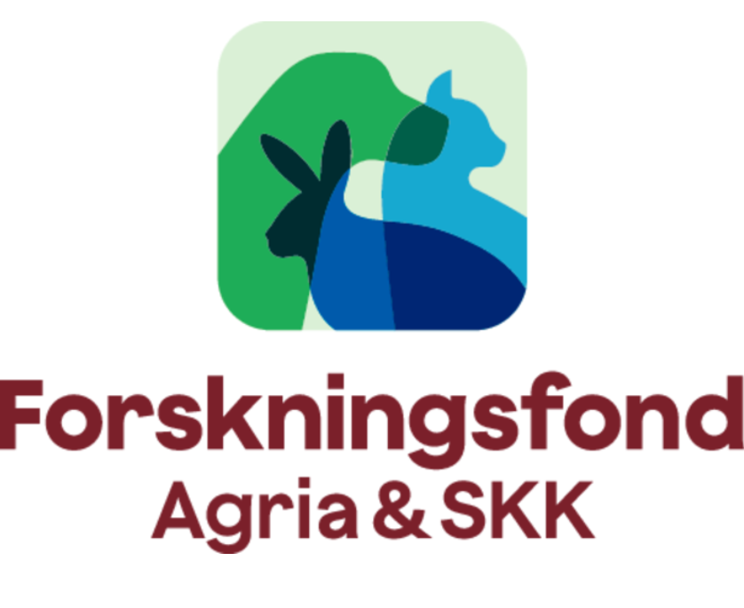

Handbook for applicants

CONTENTS
Introduction
Research areas
Ethical guidelines
Overview of the application process

Instructions for applicants

1. Call for proposals
2. Applicant
3. Language
4. Registration
5. Electronic application
6. Project title
7. Finance
8. Application Stage 1
9. Application Stage 2
10. Information about the applicant
11. Submitting the application
12. Assessment and decision
13. Contract
14. Application ongoing projects
15. Final reports
Financial final report
Scientific final report
- Publication
17. Postponement
18. Publicity and communication

Introduction

This handbook is designed for those who are applying for a research grant from Agria Djurförsäkring and the Swedish Kennel Club Research Fund (hereinafter referred to as the Fund).

The common purpose of the Fund is to promote high-quality scientific research
relating to dogs, cats and other pets in those areas prioritised by the Fund.

The Fund is administered through the office of the Swedish Kennel Club (SKK). There is a joint steering group that manages the cooperation between Agria Djurförsäkring (Agria) and SKK and this is the Fund’s governing body, which also has responsibility for the Fund’s organisation and general matters. The Fund’s Research Committee is the body that assesses incoming applications.

The members of the Research Committee have been chosen based on scientific competence and anchoring within the Fund’s prioritised research areas. The Committee decides which Stage 1-projects proceed to Stage 2. At Stage 2, the Committee submits proposals to the Fund’s steering group for projects that are to be granted funding. Final decisions are then made by the CEO of Agria and SKK, respectively, following the suggestions of the steering group.

Research areas

The Fund finances research into veterinary medicine, genetics and ethology, as well as research into the mental, social and economic importance of pets for humans and society.

The Fund prioritises the following research areas:

• The physical and mental health, performance and welfare of companion animals
• The reproduction and rearing of companion animals
• The role of companion animals for humans and society

The Fund is also interested in systematic surveys and meta-analyses in order to collate the literature available in the above research areas.
Sixty per cent of the funding in the call for proposals is allocated to research into veterinary medicine, genetics and ethology, while 40 per cent is allocated to the role of companion animals for humans and society.

See also Research and Development Programme for Agria and the Swedish Kennel Club Research Fund for Companion Animals 2025–2026.

Ethical guidelines

Through the research projects, the Fund works to enhance animal health and improve animal husbandry, but also to create peace of mind for animals and their owners in the long term.
With regard to veterinary projects the Fund only finances research projects that benefit the animal species concerned and which aim to provide many animals of the same species with a healthier and more sustainable life.
The Fund does not contribute funds to projects where animals are subjected to suffering or to unnecessary or painful animal testing.
For all studies that require a permit, this must be reported to the Fund before grant funding is paid. The research application must indicate whether the trial application has been, or will be, submitted.

Overview of the application process
Stage 1
- Register a new application in the Fund´s electronic application system
- Write a concept proposal covering no more than three A4 pages plus CV and publication list
- Submit the concept proposal via the Fund’s application system
- The Research Committee decides which applications are approved to proceed to the next stage (Stage 2)
Stage 2
- Write a full-scale application
- Submit the application via the Fund’s application system
- The Fund decides which projects have been granted funding

’

The call for proposals takes place in two stages and in the first stage, Stage 1, the applicant submits a brief description of the proposed project, focusing on the project’s relevance and benefit for the pet sector alternatively pets role for humans and society.
The application must state any use of laboratory animals, patient animals, private animals or human subjects. Those Stage 1 applications that are approved proceed to the next stage, Stage 2. The applicant must then submit a full-scale application that is evaluated on the basis of its relevance and scientific quality.

Applications can be made for funding periods of 1, 2 or 3 years. An application can be made for a maximum of SEK one million per year including overhead costs (OH), which may amount to no more than 25% of the sum for which the application is made. All costs must be stated in Swedish crowns (SEK).

Funding applications can be made by researchers in Sweden, Norway, Denmark, Finland and Germany. The main applicant must hold a doctorate or have equivalent scientific experience and be affiliated with a university, research institution or other organisation such as an animal hospital. The Fund welcomes collaboration between research institutions in different countries.
If you have any questions, please contact the Research Fund Secretary:
Annika Klang
Email: forskningsfonden@skk.se

Instructions for applicants

1. Call for proposals
The system is open for Stage 1 applications from 1 to 30 April and for Stage 2 applications from 1 to 30 September.

2. Applicant
The main applicant must hold a doctorate or have equivalent scientific competence and be affiliated with a university, research institution or other organisation such as an animal hospital.

Language

Applications must be written in Swedish/Danish/Norwegian or English.

- Registration

Applications must be made via the Fund’s electronic application system: www.hundforskning.se.

In order to use the system, the applicant must be a registered user and have an account login. An account is created by clicking on the heading Apply direct and then For researchers. Select New user and follow the instructions. During registration, the applicant must provide their email address. A password is created automatically for login and is sent to the email address provided. The user name, password and applicant’s email address are required every time you log in.

5. Electronic application

The application system contains several tabs and all the fields must be completed and saved before the application can be submitted.

On the Home page, you can add and edit personal details and create a new application. The home page automatically displays the application created and its reference number. Open the application by clicking on the reference number, then select Edit. The various sections of the application can then be completed in any order. Always use the Back button on each page to return to the home page.

You can open and make changes to the application right up to the deadline. To do this, use the Resume link. Once you have made a change, the application must be resubmitted using the Submit link. Only the most recent version is available to the Fund. Any changes should always be made to the original application.

6. Project title

The title of the project must be concise and contain no more than 80 characters.
- Finance

Indicate how the project is intended to be financed. Please note that all amounts must be given in Swedish Crowns (SEK). Details must be given of any funding granted to the project by other financers. It must also be indicated whether funding has been applied for from other financers to cover the costs also applied for to the Fund.

The Stage 1 application should provide an outline budget for the project´s costs.

The budget in the Stage 2 application must not deviate substantially from the outline budget in Stage 1. All costs must be clearly indicated and itemised for the part of the project that the Fund is intended to finance. Budget items such as “other materials” or “miscellaneous expenses”, will not be accepted. Funds for participation and presentation of current research at national and international conferences are granted up to a maximum of 10 % of the amount applied for.

The overhead costs may not exceed 25% of the total sum applied for, including salaries and faculty, departmental and university overheads, as well as premises costs.

The names and positions of all those involved in the project must be provided. The scope of the work of the participants in the project must be indicated as a percentage of a full-time equivalent and then the monthly salary.

- Application Stage 1

The application is an overview, a concept proposal, of the project and may consist of no more than three A4 pages, plus CVs and reference list which must not exceed two A4 pages. Example of font is Calibri 12 characters. The description should focus on the relevance and practical benefit of the project for the pet sector or the impact of companion animals on humans and animals.

The application should include the following:

- A brief description of the project including purpose, goals and expected results
- Whether laboratory animals, patient animals, private animals or human subjects are included in the study
- Any preliminary results
- The total amount of funding applied for, with reasoned justification
- Other participants in the project team

In the application form, applicant must indicate whether they wish to use data from Agria Djurförsäkring.

The application must also state whether any applied for or granted contributions may come from an insurance company other than Agria.

- Application Stage 2

Researchers who have had their applications approved in Stage 1 must submit a full-scale application in Stage 2. The project description should focus on the relevance of the project and the practical benefits for the pet sector or on the importance of companion animals for humans and society.

The project description must cover no more than 10 A4 pages and should include the following:

- A clear summary of the project
- The purpose, objectives and expected results of the project
- Materials and methods
- Whether laboratory animals, patient animals, private animals or human subjects are included in the study
- Composition of the project team
- A summary of the research already carried out in the field and a description of how the project applied for links to previous research
- National and international collaborations
- The amount of funding applied for must be indicated so that it is clear how it will be used
- Ethical considerations
- A plan for the scientific publication and dissemination of information

CVs including lists of publications relevant to the project must not exceed three A4-pages (12,000 characters).

- Information about the applicants

Provide details of the main applicant and the co-applicants for the project. The main applicant must hold a doctorate or have well-documented research skills and experience of leading research projects. For doctoral projects, the main applicant must be the doctoral student’s supervisor and the co-applicant must be the doctoral student.

The main applicant is responsible for ensuring that the project proceeds according to plan, that the application for continued funding is submitted for multi-year projects and that final financial and scientific reports are submitted within the specified period. The main applicant is also responsible for the accuracy of all the financial reporting to the Fund. The research secretary must be notified if the main applicant resigns or retires.

CVs, including the list of publications should contain a brief description of the applicant’s qualifications, along with a list of their most recent relevant publications. The name of the applicant should be highlighted in bold in the reference list. Reference should only be made to information that is relevant to the project.

- Submitting the application

Once the application has been fully completed, it should be submitted electronically using the Fund´s application system by clicking Submit in the Fund’s application system, www.hundforskning.se. A check is then made that all the required information has been completed.

The application can be printed out by clicking Print on the home page. The entire application will then be displayed in a new window, where you can choose to view and/or print the document.

The application should also be submitted in the application system as a PDF file.

- Assessment and decision

All applications are assessed by the members of the Research Committee. The basis of the assessment is the scientific quality and relevance of the application for the pet sector or the importance of pets for humans and society as well as whether the proposed projects align with the Fund’s research and development programmes and prioritised areas.

For Stage 1 applications, the Research Committee decides which projects are invited to submit a more detailed application in Stage 2. For Stage 2 applications, the Steering Group suggests which projects should be granted funding, following a proposal from the Research Committee. The final decisions are made by the CEO of Agria and SKK respectively.

Where projects have applied for funding for more than one year, the Fund reserves funding for the number of years indicated in the application. In order for the reserved provisional amounts to be disbursed, an annual application for continued funding, including an account of the progress of the project, must be submitted via the electronic application system during September and must receive the approval of the Fund.

The main applicant will be notified by email at the beginning of the following January whether or not the project has been granted funding. Information about the projects awarded funding is also published on the Fund’s website. Decisions are final and there can be no appeals.

13. Contract

For those projects that have been granted funding, the main applicant must print out a contract, sign and send by email to the Fund. A signed contract is returned to the main applicant.

The contract is a legally binding document and contains information taken from the relevant application. The contract sets out the obligations of the applicant and the third-party agent, as well as the reporting requirements for the project. The contract also includes a payment and publication schedule. Once the contract has been signed, the administrative bodies will requisition the funding granted from the Fund by sending an email to forskningsfonden@skk.se. For all studies that require any permit, this must be submitted before grant funding is paid.

- Application ongoing projects

Where projects have been granted funding for more than one year, an annual application for continued funding must be submitted before the funds are disbursed. This must take place in September via the Fund’s application system. The application must indicate what has been done during the year, along with any deviations.

The research secretary must be contacted in the event of any major deviations, such as a change of main applicant or other change in the project. Major deviations may result in the suspension of funding and the recovery of funds already disbursed.

15. Final reports

On project completion, a financial final report and a scientific final report must be sent to the Fund electronically at www.hundforskning.se. The final reports must be submitted no later than 12 months after project completion.

Before a funding application for new projects can be made, previous projects must be reported according to the current timetable.

The final reports must be submitted in the application system as PDF files using the same login as for the application.

Final reports are submitted to the Chair of the Research Committee for approval. Reports that are approved will be published in a project bank on the Fund’s website and used as a basis for disseminating the results.

If the final report is not submitted, despite reminders, the project will be cancelled and the Fund may demand repayment of the sums granted and disbursed. Cancelled projects will not be published in the project bank.

Financial final report
All costs must be reported in a way that clearly shows how they have been charged to the project. The accounts must relate to the budget indicated in the original application.
Funds not used in the project must be paid back to the Fund.

Scientific final report
The report may cover no more than six A4 pages, including reference list, and must be written in Swedish/Danish/Norwegian or English.

The scientific report must include the following headings:

- Project title and project number
- Author of the report
- A popular science summary
- Introduction, background, purpose and question at issue
- Materials and methods
- Results
- Discussion with conclusions and practical benefit for the pet sector
- Publications

Provide links to relevant publications or other popular science reports written as part of the project. Also provide links to web pages describing the project.

16. Publication

The approved final reports will be published, together with the contact details of the main applicant, in a project bank on the Fund’s website and used as a basis for disseminating the results to the sector. If publication by the Fund may prevent the planned publication of a scientific article or in the event of a patent application, the postponement of publication must be requested.

The results of the activities carried out within the framework of the agreement between the principal researcher and the Fund will be made public through so-called Open access.

17. Postponement

If the project cannot be reported according to the original timetable, a written application for postponement must be sent to the research secretary by email. This application must clearly explain the reason for the delay and include a new timetable. Postponement will only be granted in exceptional circumstances, such as illness, unforeseen delays or unforeseen restructuring of the project team. Postponement is granted by the Chair of the Research Committee.

18. Publicity and communication

The research results are expected to be published in one or more scientific journals. The research grant holder undertakes to assist journalists with the Fund’s commission to publish the findings of projects in popular science publications.

For communication about the project in both digital and printed materials, the Foundation´s logo must be used in accordance with the guidelines on the website.

In all communication and publicity for the project results, it must be indicated that the project has been financed using funding from Agria Djurförsäkring* and the Swedish Kennel Club **Research Fund.

It is desirable that recipients of research grants from the Fund are able to present their project at seminars or in the form of digital lectures.

Good luck with your application
The Research Fund

March 2025

Terminology:
*Agria Djurförsäkring is one of the world’s leading pet insurers, founded in Sweden over 130 years ago, with operations in nine different markets across Europe
** Svenska Kennelklubben, the Swedish kennel club, founded over 125 years ago, is Sweden's largest organization dedicated to dogs and dog owners.

